In home in Shopify Admin:
Home Module:

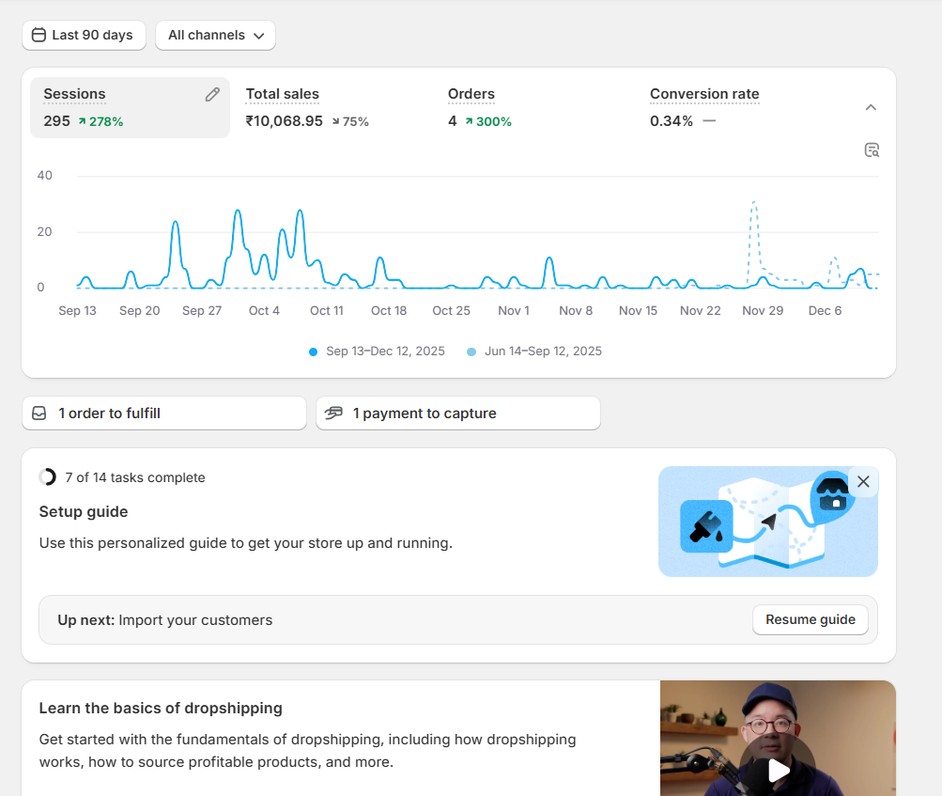
Path: Admin page> Home

*Date Select:
*Channel Select:
POS
which warehouse
Online store (our website)
Facebook or Instagram
Google and Youtube(link all google links(GSC, GA4,GTM,Microsoft Clarity))
Buy Button(In external site our product link added like( "add to card " or " buy now "))
Others
*We can see the number of live users in this page.

*Check the unmber of orders to fulfill here (like n number of orders are * received here, we have to fulfill this
order)
Payment to capture (we have to capture the N number of customers payments)

*Setup Guide
Store setup guide like add products and payment gateway, shipping charge details, import customers.

*Basics of dropshipping
Dropshipping is a business model where:

* You sell products on your Shopify store.
* You don’t keep any stock.
* When a customer buys something, you order it from a supplier.
* The supplier ships the product directly to your customer.
* So you don’t touch the product at all.

*We integrate third-party products into our store and sell them, while the third-party supplier handles the
Inventory and shipping directly to the customer.

*Dropshipping basically means you sell products on your Shopify store without keeping any stock—when someone
orders, you simply buy it from a supplier who ships it directly to the customer, so you never handle the product
yourself.

AliExpress:
*The vendor ships the product directly to the customer, but AliExpress only shares the shipping
details required for delivery—not the customer relationship.

Printify:
*The vendor ships the product directly to the customer, but Printify only shares the shipping
details required for delivery—not the customer relationship.

*Claim domain

*Simplify Marketplace Selling
sell products across all online marketplaces top platforms like amazon, flipkart, ebay, walmart.

*Sell products through social media
most of the buyers buy products from the social media like facebook, instagram, tiktok and etc mostly.

So, bring your products in social media platform and enhance product sales.

*Grow your influencer business with apps
influencers share your product link, you get the sales from their followers, and you pay the influencer a
commission for each sale they help generate.

*Drive Traffic
use marketing tools (meta ads, google ad, Email Marketing) to attract more potential customers.

*Improve conversion
convert more customers faster with built-in-tools.
- Google Ads
- Meta Ads
- Email Marketing
- Shopify Discount
--------------------------------------------------------------------------------------------------------------------------------------------------------------------
Sales channel list
Online store
Inbox (online chat box tool) -- Sales or interactions coming through shopify inbox chats
Facebook and Instagram -- order placed through your connected meta sales channel (Shop app, IG Shop)
Buy Button -- Sales made through embedded buy buttons on external website/blogs
POS - Point on Sale
Chennai Warehouse
Pune Warehouse
Bengalure Warehouse
PO - Purchase Order

--------------------------------------------------------------------------------------------------------------------------------------------------------------------

Orders:
We can track all products ordered in different channels, when products payment status is completed or what status.
Drafts:
only used when manually billing entry ordered or when we can send quotations.
-------------------------------------------------------------------------------------------------------------------------------------------------------------------
Products:
Collection --(products collection like Television, Refrigerator, Washing Machine, Mobile, furniture, home theatre)
Inventory -- (list of prouducts, we can change the quantiy and so many details like committed products, stock
availability, we can add status of the products like damaged, newly received)
Purchase -- Order (buy bulk orders from third party vendors)
Transfer -- (one warehouse to another warehouse)
Gift Cards--(we can sent only when we have a valid customers)
--------------------------------------------------------------------------------------------------------------------------------------------------------------------
Customers:
list of our customers can show.

Customer_Segments:
Customers who purchase at least once
Email subscribers
Abandoned checkouts in the last 30 days
Customers who haven't purchased
* We can create a new customer segments

This query in create customer segment is called Shopify Customer Query Language

FROM customers
SHOW customer_name, note, email_subscription_status, location, orders, amount_spent
WHERE abandoned_checkout_date >= -30d
ORDER BY updated_at

This query is called Shopify Customer Query Language.
-------------------------------------------------------------------------------------------------------------------------
Marketing
Email -- It will redirect to email
we can create a campaign (one mail to send customer list)
We can create automation workflow (a set of email to be sent once after another in a
sequence automatically)

Campaign -- Single Mail (often tell campaign) by done manually

Automation Workflow -- a series of steps that run automatically without Manuel Work.

Attribution Model:
Last non direct link:
Direct channel is ignored, 100% credit given to the last channel clicked
Last Click:
100% credit given to the last channel clicked
Fisrt Click:
100% credit given to the first channel clicked
Any Click:
100% credit given to the each channel clicked
Linear:
Equal credit given to each click.

Top Marketing Channels:
Direct -- physical Store
Google Search -- came through Google Search
Shopify Apps -- came from Shopify apps (shop)
Facebook -- Came from the facebook app
Shopify -- organic online store

Recent Campaigns: We can check the recent campaigns we created

Marketing App activities: The app (Messaging) we used and make progress(send mail, campaigns, automated workflows)

CAMPAIGNS
we can create a campaigns in this sub section.
--------------------------------------------------------------------------------------------------------------------------------------
Discounts:
Amount off products:
Discount for specific products or collections of products
Buy X get Y
If customers buy X products and they can get Y products
Like if they buy 5 products and they can get 1 Product free of cost
Amount off order
Discount the total order amount Spent.
Total bill amount – Discount Amount
Free Shipping
Offer free shipping on an order

--------------------------------------------------------------------------------------------------------------------------------------------------------------
Content:
MetaObjects:
It's a library of features or details you create once and use for many products.
Files:
This all your data files are shown we can select the any one of the file and copy the link and put in a new tab
it will display the original file such as image or video.
Menus:
This menu editor is where you build your website's navigations.
It is important because it controls how visitors move around your store and find products.
------------------------------------------------------------------------------------------------------------------------------------------------------------------
Product Page:
This page is used for selling products, Each product automatically gets its own page.

contains images, pricing, buy buttons, specifications and descriptions.

Pages (Static Pages):
These Pages are standalone pages for permanent information.

like,
About Us, contact, Warranty Policy, Track your order, Installation Service, FAQS, Service Pages.

Blog Posts:
These are articles that belong to a blog.
EX:
Best 4K TVs To Buy in 2025.
How to choose a Home Theatre Style.

Collection Page:
Automatically creates for a collection.

Home Page:
The Main landing page of your store.

Edited using the Theme Editor, not Pages.
--------------------------------------------------------------------------------------------------------------------------------------------------------------------
Market:
Where you want to sell and how you want to sell in each region.

It Controls:
Currency
Language
Domain and subdomains
Shipping zones
Product availability
Prices
Duties and Taxes

Markets lets you choose which countries you ship to.

Markets controls selling regions.

In that we can set the shipping charges for a countries.

By Using market conditions we can select the list of countries to sell the products.

A parent market:
The market that covers the largest region

The Sub Market:
The Market that covers small region with unique rules.

Catalogs In Markets:
Catalog is a list of products + Modified prices for a specific market.
used to control which products appear and how they are priced in each country / region.

------------------------------------------------------------------------------
Saas -- If customers use the software as a service (subscription) - SaaS -- Pay amount for the servide like netflix they build the software on a hosting and we can access it through online only.

------------------------------------------------------------------------------

Metrices - Measurable numerical values used to track store performance.

Session -- When a visitor comes to your store and interact with your websites.

one visitors can have multiple sessions in a day.

So, Session track visits.

Order -- All metrices that measure money spent, money earned and profit from customer orders.
* how much profit is made per order
* whether shipping is costing too much
* If discounts are affecting revenue

Finance:
How much money customers still have in gift cards and credits.
How much credit you have issued.
Whether payments are failing.

Behavior:
It is a metrice show how customers behave inside your store -- what they click, view, submit and buy.

Used to improve conversion rate, increase sales, optimize product recommendation, improve user experience,
understand customer interest.

Dimensions:
Dimensions are categories to divide and analyze your data.

A category is a label used to group similar products, data, or information.

If metrice = sales = 50,000

Dimensions help you understand Where, When, and how that numbers happened.

Dimensions let you break it like:
By Month --> Sales in Jan, Feb, March
By Day of Week --> Sales on Monday, Tuesday
By Country --> India, US, UK sales

* Break down your data
* Compare Performance
* Analyze customer Behaviour
* Filter reports
-------------------------------------------------------------------------------------------------------------------------------------------------------------------

StoreFront:
* Storefront is the version of your website (shopping and browsing) that customers see when they
visit your Shopify store.
* It automatically adjusts to show the right country, currency, or
language for each visitor.
* This ensures customers have a smooth shopping experience based on their location.

Storefront – Customer sees it – Shopping and browsing
Admin – Store owner and staff – Managing store operations
-------------------------------------------------------------------------------------------------------------------------------------------------------------------
Point on sale: (POS)
Unlimited POS accounts:
* You can create as many POS staff accounts as you need for your
retail store team.
* You can track individual staff performance, sales, and activity.
* Helps maintain accountability and accurate reporting.

Custom roles and Permissions
Define different access levels for your staff.

* Give specific permissions (process refund, apply discount, view
report)
*Assign staff to specific store locations.
Examples:
* Cashier -- can only make sales.
* Manager -- can only access reports and approve discounts.
* Admin -- Full Access.

* Like Prevent unauthorized discounts or refunds.
* Processing high value refund.

* Helps Measure staff performance.
* Useful for rewarding top performers.

POS Settings:
* Language -- Set the language for the POS app
* Subscription -- for POS locations you can to pay amount for the
services for that we have to subscribe.
* POS apps

POS Apps:
* This setting lets you control and manage all the apps used in your
physical store POS directly from your shopify admin.

When in our physical store we installed so many apps for discount, automation, shipping and fulfillment apps, Analytics and reporting Apps, Discount, Offers & Upsell Apps and etc in shopify admin we use the option in POS Apps we can make changes in online.
like if I want my pos store in Pune to create a discount for 10% offer for the products then i can do it with my laptop without needing to visit the store or need to login into POS accounts or anything.

* Page customization:
* Layouts
* Lock screen
* Receipts

* Checkout:
* Payment methods
* Customer receipt selection:
get customer email at checkout and send remarketing details.
* Offline payments
Accept credit/debit cards during internet or system outages.

* Orders:
* Define when products are ineligible for return like a discounted product, like before one week we can
return, after one week we can’t take return of the product.

*Inbox:
* It is a live chat tool.
If customers asks about a query releated to product or service we can share the product or service
link from that we can generate the profit.

